l4-sample.R

anhtran

2022-10-06

# This is a comment  
x <- 1:50   
plot(x, sin(x))

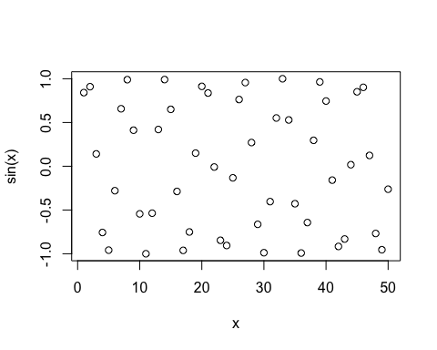

# Add more inout arguments to get this how we want it   
plot(x, sin(x), typ="l", col="blue", lwd=3)

